How to increase memory on azure servers:

1. login to the azure portal.
2. Open virtual machine page and select the server on which memory/CPU to be resized.
3. In the left menu click on **Overview** to see current size (CPU and memory) allocated.

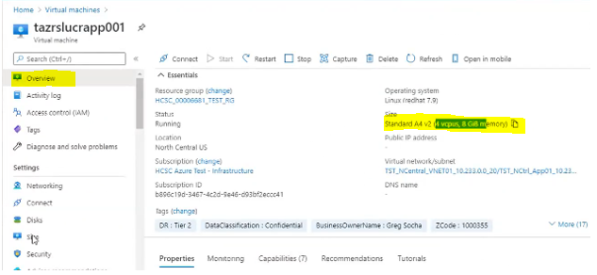

1. In the left menu click on **Size** to check available size.

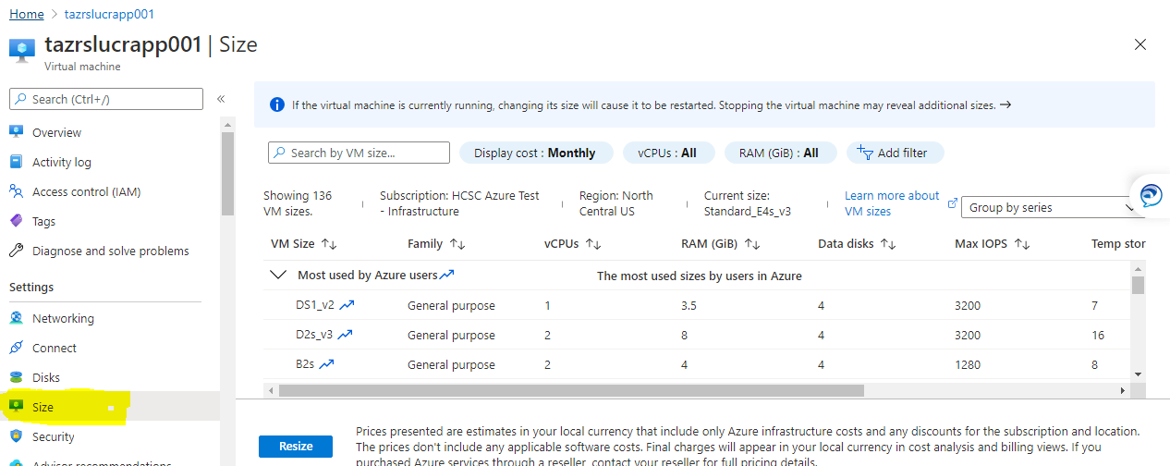

Note : In Cloud due to specific predefined VM size,  CPU and Memory most likely will be increased together if we don’t see the option for just one of it.

Example: If memory need to be resized to 32 GB.

click on RAM – custom - to see all available size for 32GB memory.

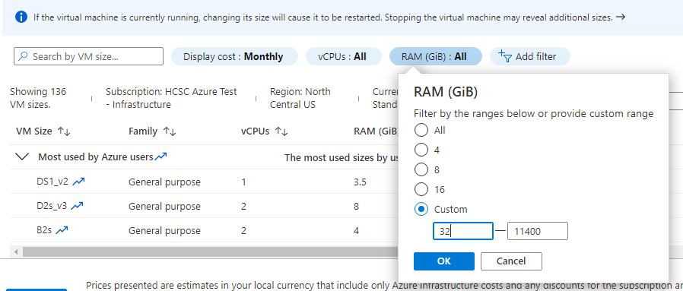

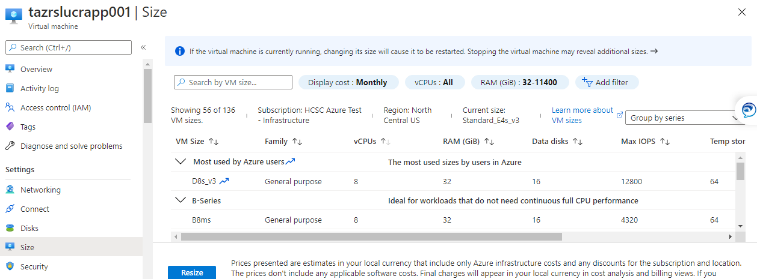

1. Select the desired size and click on **Resize**. The server will be rebooted.

Note: If the virtual machine is currently running, changing its size will cause it to be restarted. Stopping the virtual machine may reveal additional sizes.

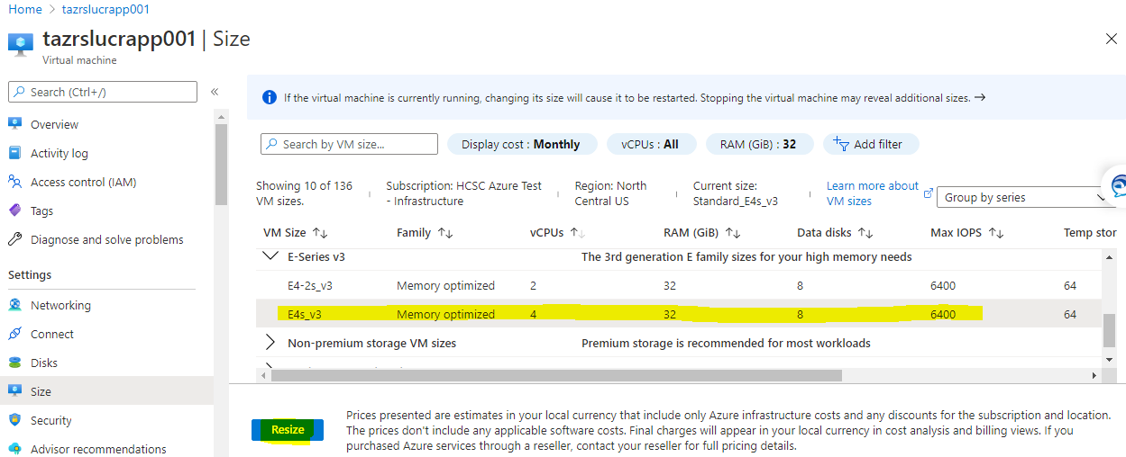

1. Once server is up verify.

